Automatic Teller Machine (ATM) System

Use Case Diagram
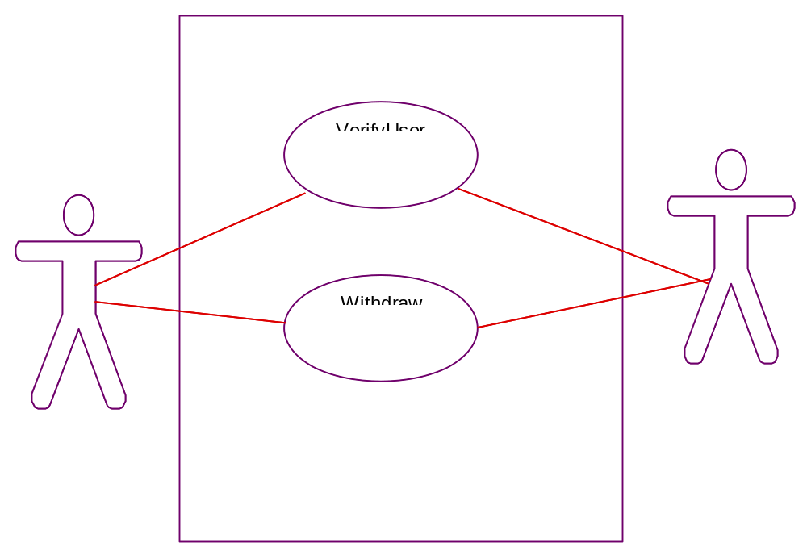
Sequence Diagrams

VerifyUser
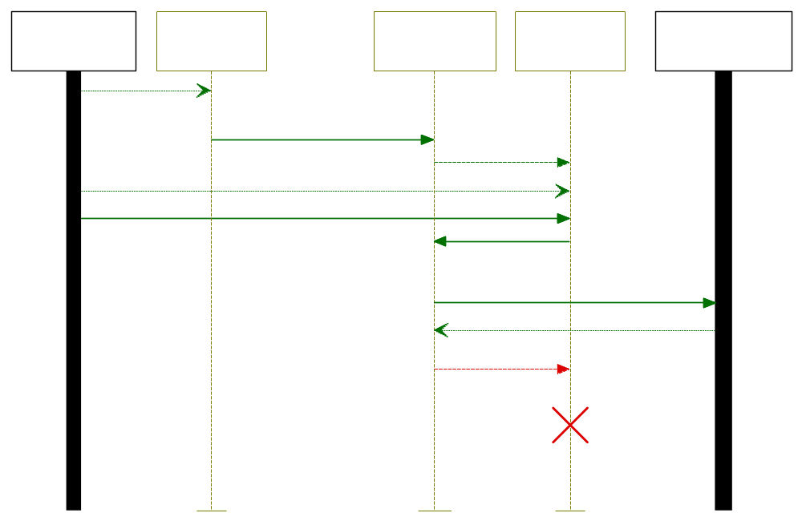
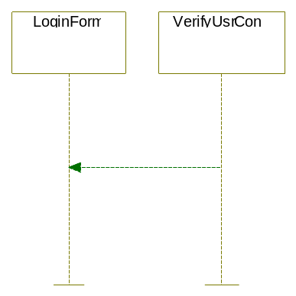Note: part of VerifyUser sequence, if user is invalid
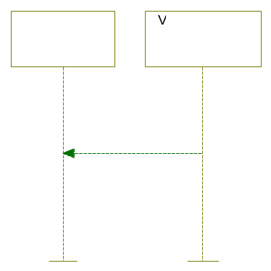Note: Part of VerifyUser if user is valid

Withdraw
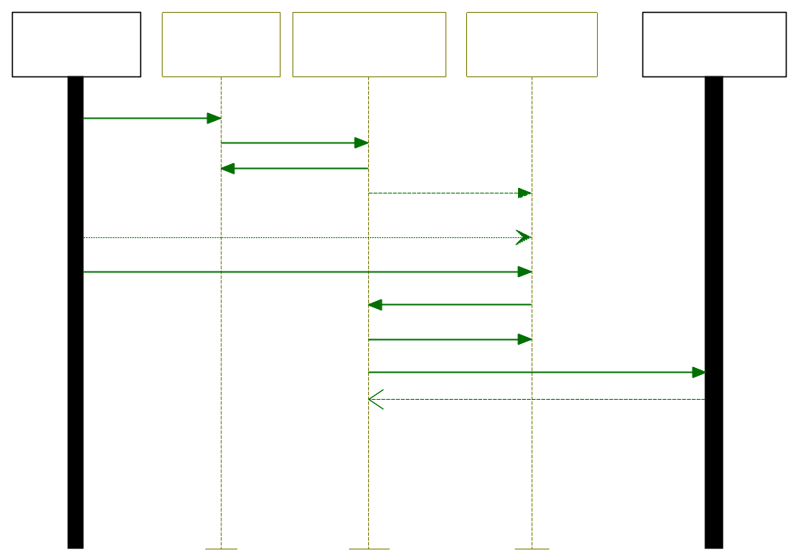
Withdrawavail (with sufficient funds)
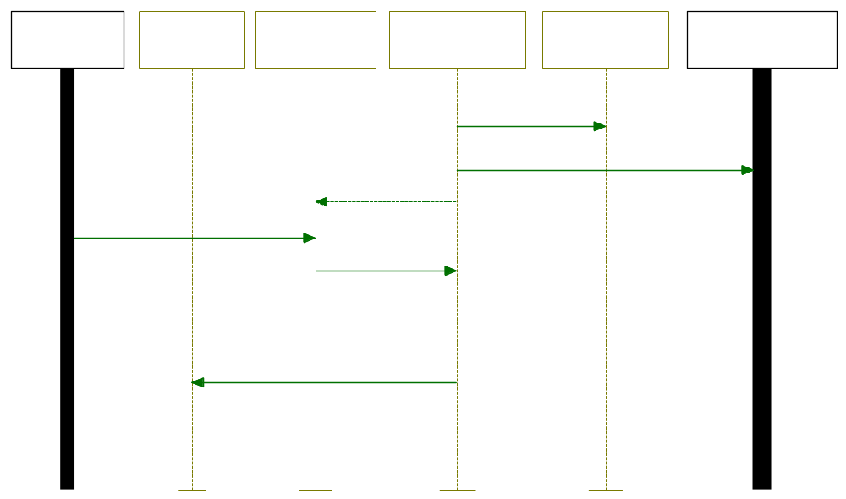

Models were created using IBM Rational Modeler hence they look slightly different from MS Vision models. This model also includes interaction with an existing database, as an actor.

